|  |  |
| --- | --- |
| cetlogo ***CHEMICAL ENGINEERING TRANSACTIONS***  ***VOL. xxx, 2025*** | A publication of  aidiclogo_grande |
| The Italian Association  of Chemical Engineering  Online at www.cetjournal.it |
| Guest Editors: Bruno Fabiano, Valerio Cozzani  Copyright © 2025, AIDIC Servizi S.r.l. **ISBN** 979-12-81206-xx-y; **ISSN** 2283-9216 | |

HAZARDS ASSOCIATED WITH LITHIUM BATTERY OVERVOLTAGES

Juan Carlos Ríos-Fernándeza,\*, Celestino González Niciezab, M. Inmaculada Álvarez Fernándezb

aUniversity of Oviedo, Department of Energy, Polytechnic School of Engineering of Gijón, 33203 Gijón (Asturias). Spain

bUniversity of Oviedo, Department of Exploitation and Prospecting Mines, Polytechnic School of Mieres, 33600 Mieres (Asturias). Spain

\*riosjuan@uniovi.es

Energy storage technologies, including lithium batteries, are indispensable to the process of decarbonization. This study is concerned with the behavior of lithium batteries with a manganese dioxide cathode in the event of overvoltage and the associated hazards. A dynamic battery model was employed in this study, which utilized a variety of battery configurations, including new and used batteries arranged in single, series, and parallel combinations. This research yielded the following primary findings. New batteries demonstrate a rapid temperature rise, even in response to low overvoltages. This phenomenon can result in gas leakage and, in extreme cases, battery fire. At high overvoltages, the temperature rises significantly in partially discharged batteries, while in discharged batteries, the temperature increase is minimal. A notable increase in temperature was observed in parallel battery configurations relative to series arrangements, with the highest temperature recorded in the parallel-connected battery. The findings of this study are of significant value in the context of the adoption of thermal insulation measures, safety measures against fires and explosions, and safer arrangements of batteries when used in isolation or with series or parallel connections.

1. Introduction

Storage technologies, such as lithium batteries, play a fundamental role in the decarbonization of the transportation sector (Stampatori et al., 2020) and the greater integration of intermittent renewable energy technologies into the grid (Kim et al., 2023). However, the use of batteries poses several safety challenges, including the potential for exposure to high temperatures (Sang-Bo, 2016) and the need for safe charging procedures (Zhu et al., 2019). These risks can manifest as fires (Diaz et al., 2020), explosions, and the release of toxic gases (Lisbona and Snee, 2011), posing a significant hazard in both industrial environments and domestic applications. There are different types of lithium batteries on the market, which basically differ in the chemical composition of their cathode. For example, there are batteries with cobalt oxide, iron phosphate or manganese oxide cathodes. Cobalt oxide cathodes are expensive and have a high level of toxicity when they reach the end of their useful life and become waste (Wen et al., 2012). Iron phosphate batteries achieve lower energy densities than manganese oxide batteries, making them unsuitable for many applications (Morales et al., 2009). For this reason, this article examines the behavior of manganese oxide cathodic lithium batteries with respect to overheating and overvoltage caused by the operating and charging processes. The results obtained should serve as a basis for the adoption of the most appropriate battery positioning and combinations from a safety point of view.

2. Methodology

A dynamic model was utilized to conduct tests on a single lithium battery with a manganese dioxide cathode and on two of these batteries connected in series or parallel, subjected to an electrical overvoltage. The batteries were subjected to a series of overvoltages, with amplitudes of 5 and 10 volts, respectively. The diverse battery configurations and overvoltage conditions permitted the collection of data on the operational and failure characteristics of the devices over an array of time periods. Additionally, tests were conducted on batteries in varying states of charge, including full charge (3 V), partially charged (2.87 V), and discharged. The data acquired encompassed the temperature levels attained on the battery surfaces, the electrical failures observed in the battery combinations tested, and the generation of smoke, fire, and explosion.

3. Results

3.1 Test 1

The test involved applying 5-volt to a charged battery over a period of 100 minutes. The battery (3 V, 800 mAh) was connected to a 5-volt source, reached 2.31 amps during the first minute, and then dropped rapidly to less than 1 amp. Also, after a nine-minute period, the maximum temperature of 82.2 ºC was reached, followed by a rapid decrease. After a 20-minute interval, the temperature increased again and then declined gradually to a range of 50-60 ºC. In contrast, two instances of gas leakage were observed at the cathode. As shown in Figure 1, the first leak occurred in less than one minute, which coincides with the maximum current read. The second leak occurred nine minutes after the test, coinciding with the peak temperature reading.

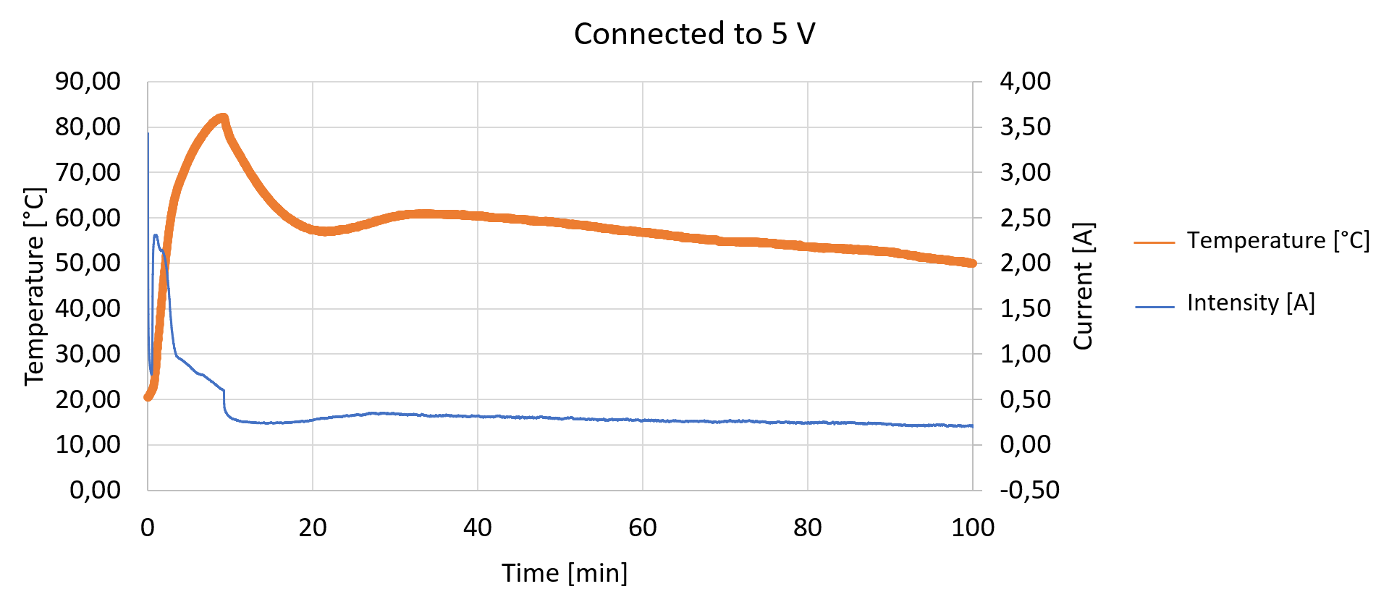

Figure 1: Temporal results of temperature and electrical intensity achieved on a charged lithium battery subjected to a 5 V overvoltage

3.2 Test 2

This test consisted of applying 10 volts to the battery from Test 1 for 190 minutes. The battery was connected to a 10-volt power source. After 1 minute, the maximum current (1.29 A) was reached, as shown in Figure 2. The maximum temperature (85.2 ºC) reached 2 minutes later. After these peaks, the temperature dropped to an interval between 40 and 50 ºC. There were no leaks at this stage, which could mean that all the gases had already been expelled while the battery was connected to 5 volts.

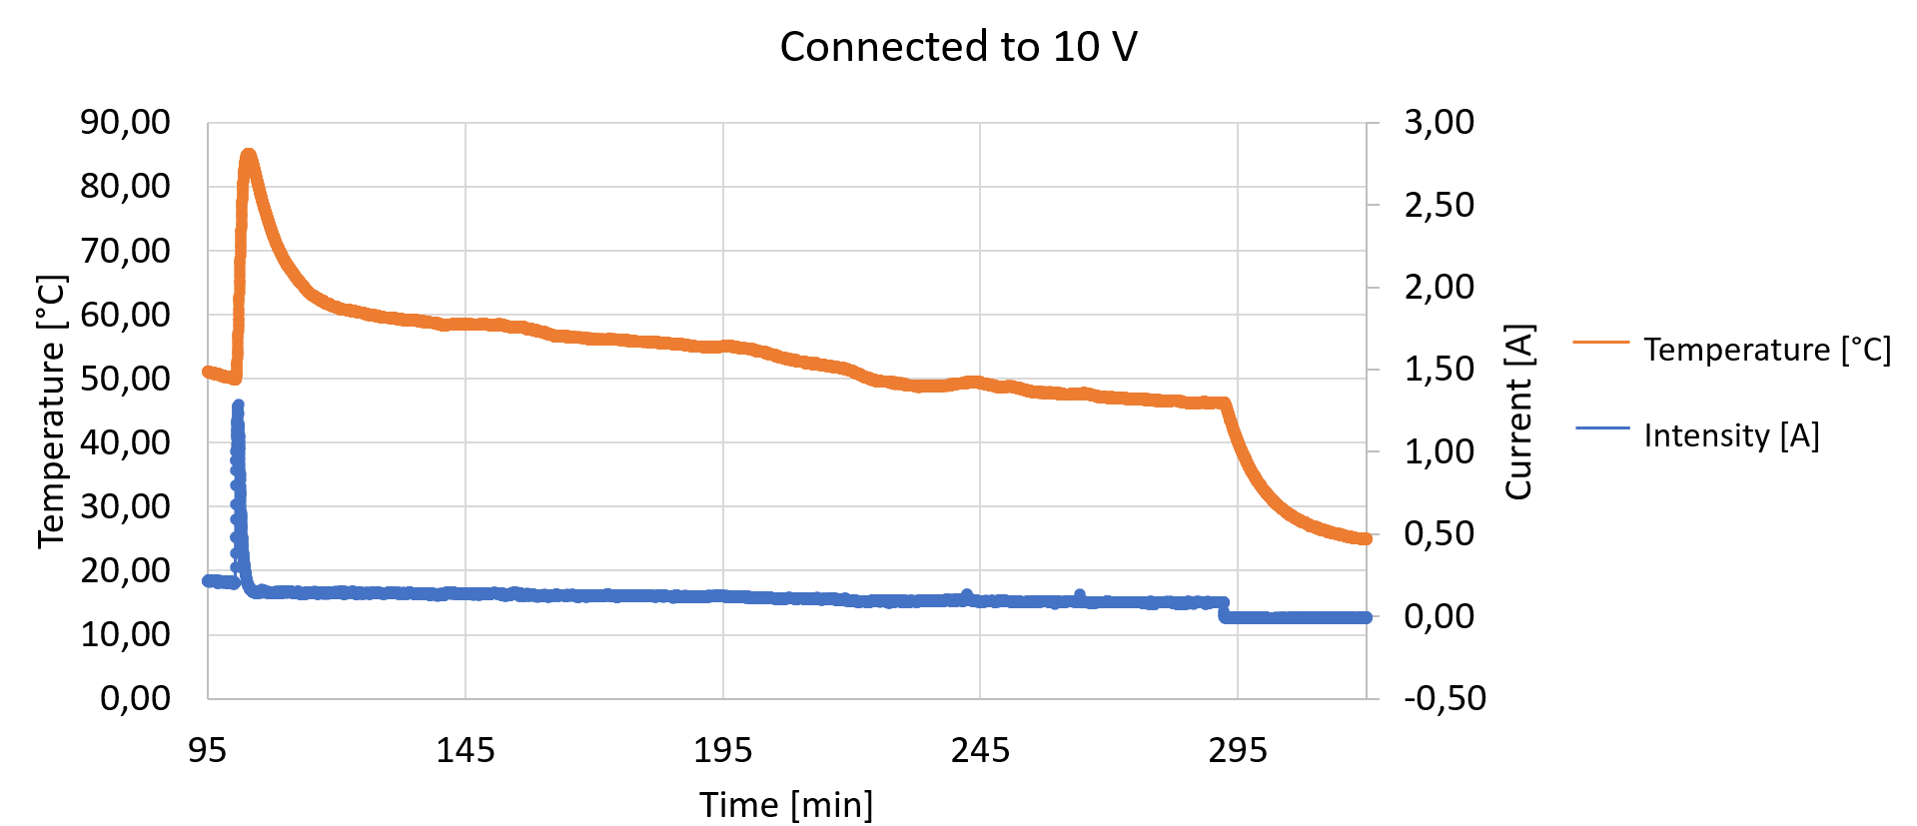

Figure 2: Temporal results of temperature and electrical intensity achieved on a charged lithium battery subjected to a 10 V overvoltage

**3.3 Test 3**

In this test, a voltage of 5-volt was applied to a discharged battery for 250 minutes. Figure 3 shows that virtually no current flows through the battery at 5-volt, although there was a slight increase in temperature at the beginning of the test due to a sudden peak in current when the power supply was connected, until this current stabilized and dropped. The temperature stayed between 20 and 22 ºC, and the current dropped to 0 amps in less than a minute. The power supply was disconnected after 220 minutes.

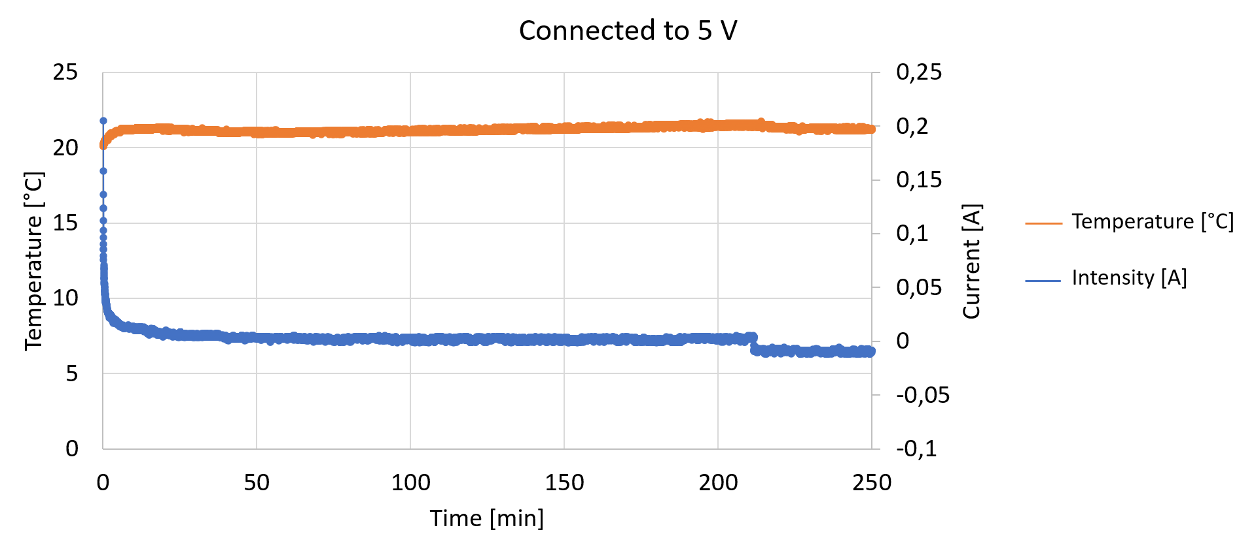  
Figure 3: Temporal results of temperature and electrical intensity achieved on a discharged lithium battery subjected to a 5 V overvoltage

3.4 Test 4

The test consisted of connecting a discharged battery to an electrical voltage of 5-volt for 144 minutes and then to 10-volt for 300 minutes. Figure 4 shows that the part of the graph where the battery is connected to 5-volt is like the previous test. That is, the same peak current and temperature at the beginning, followed by a rapid stabilization of both variables, and then the temperature remains in the range of 20 to 22 ºC while almost no current passes through the battery.

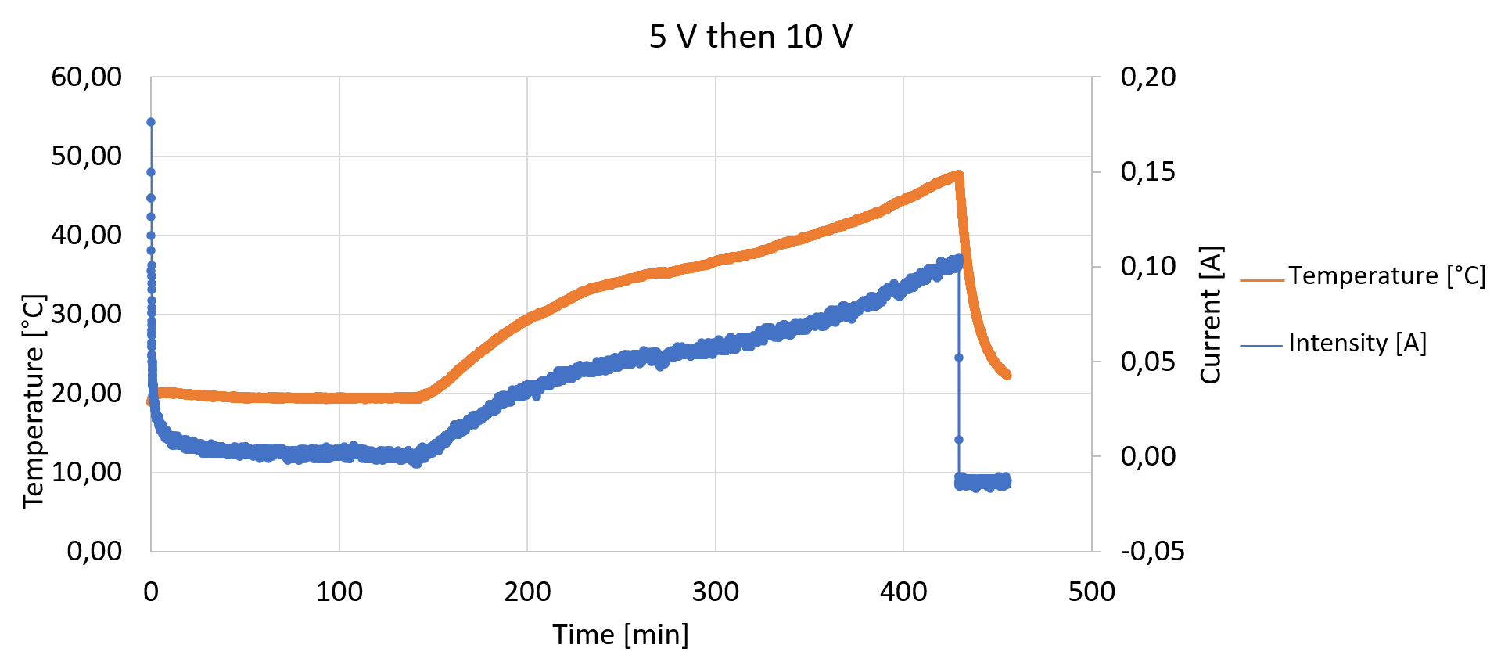  
Figure 4: Temporal results of temperature and electrical intensity achieved on a discharged lithium battery subjected to a 5 and 10 V overvoltage

When the power supply was switched to 10-volt at minute 144, no current flowed through the battery until 7 minutes later, when 0.01 amps began to flow, and the temperature began to slowly rise. The maximum temperature was 47.72 °C when the current reached 0.1 amps. This connection to 10-volt can be visualized in Figure 5.

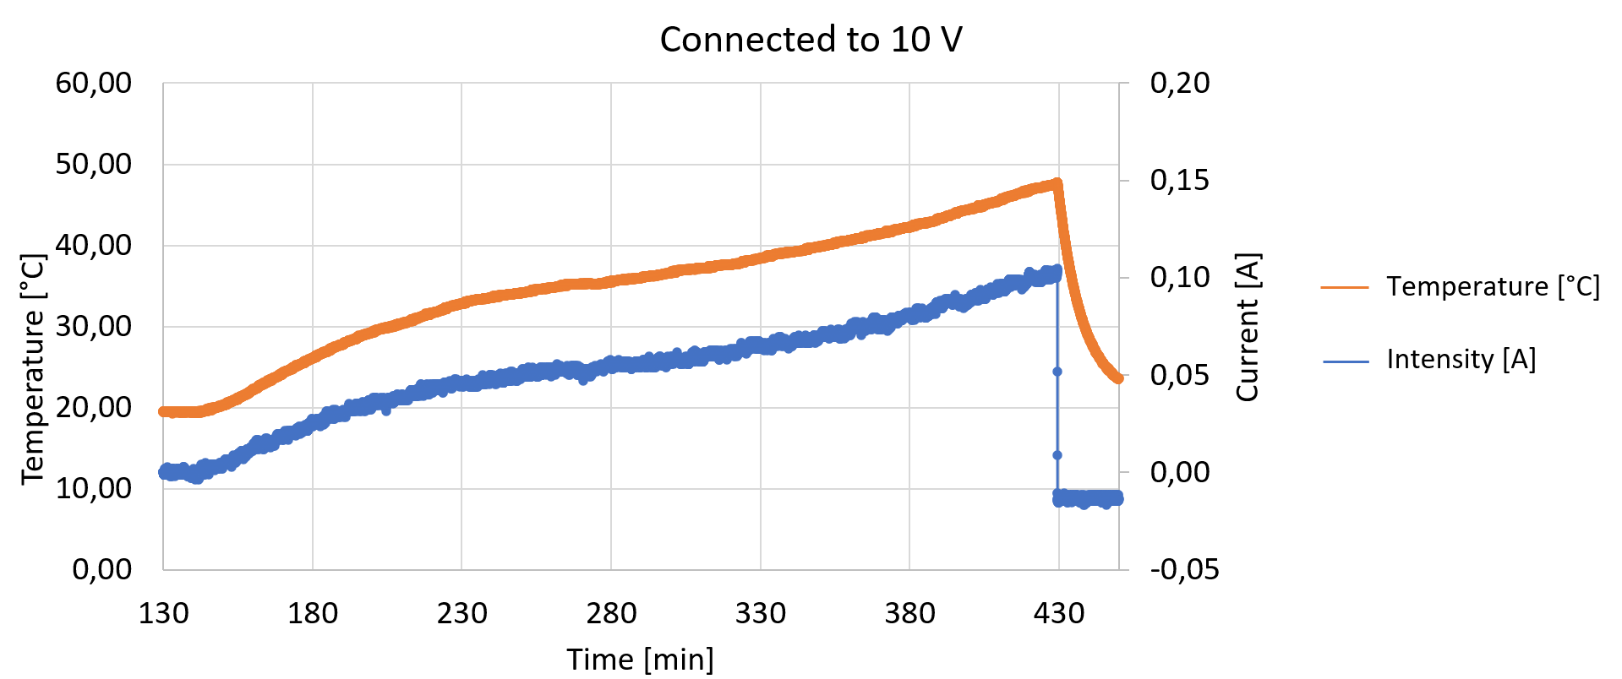  
Figure 5: Detail of the temporary results of temperature and electrical intensity achieved in a discharged lithium battery subjected to a 10 V overvoltage

3.5 Test 5

The test consisted of applying a voltage of 5-volt to a partially charged battery (2.87 V) for 135 minutes. A voltage of 10-volt was then applied to the same battery. Initially, the temperature and current remained almost constant, although a slight increase was observed. Then, when switching to 10-volt, the maximum current intensity of 20 amps was quickly reached, but then quickly decreased. This indicated a short circuit. The cables connecting the battery to the source began to burn as soon as they began to carry these 20 amps. The temperature of the battery exhibited an upward trajectory, reaching a maximum of nearly 120 ºC as illustrated in Figure 6. However, the experiment was terminated prematurely due to the failure and subsequent burning out of the current clamp.

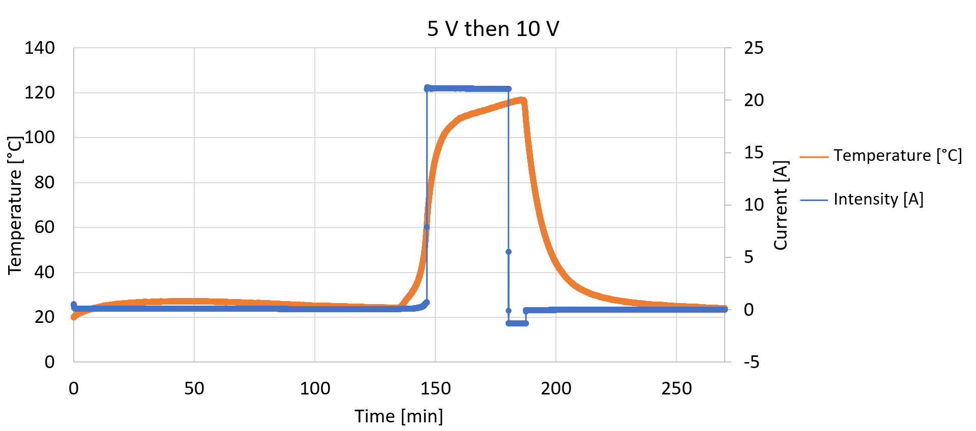  
Figure 6: Temporal results of temperature and electrical intensity achieved on a partially charged lithium battery subjected to a 5 and 10 V overvoltage

3.6 Test 6

In this test, two new batteries were connected in parallel. One of the batteries was connected directly to the power supply, while the other was connected in parallel with the first. The set was initially subjected to three 5-volts overvoltage peaks and subsequently to six 10-volt overvoltage peaks. The time interval between peaks is illustrated in Figure 7. As shown in this figure, the battery that reached the highest temperature was the one connected in parallel with the battery that was connected directly to the power supply. Furthermore, the temperature increased between peaks, except for instance when the rest of the period exceeded 20 minutes. The battery connected directly to the power supply reached maximum temperatures of 60 °C, while the battery in parallel reached maximum temperatures exceeding 70 °C. The difference in temperatures reached at each peak was approximately 10 °C, consistently higher in the battery in parallel.

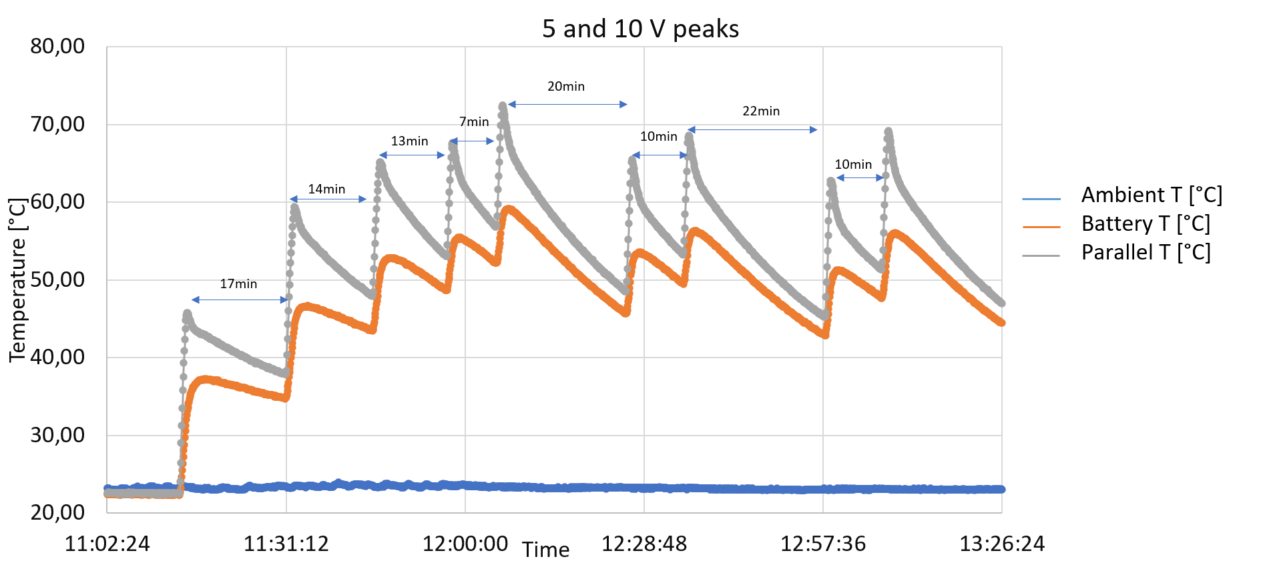

Figure 7: Temporary results of the temperature reached in a parallel connection of two new lithium batteries and subjected to overvoltage peaks of 5 and 10 V

3.7 Test 7

In this experiment, two novel batteries were connected in the series. Furthermore, the batteries were encased in a rock wool thermal insulator, with the temperature sensors positioned beneath the batteries to prevent heat leakage. One of the batteries was connected to the voltage source via the positive pole, and the other battery was connected to the power supply via the negative pole. The initial three 5-volt overvoltage peaks were applied for a duration of one minute, followed by another five 10-volt peaks applied for 30 seconds.

As illustrated in Figure 1, the highest temperature was recorded for the battery connected to the power supply via the positive pole, reaching 62 ºC. At this same instant, the highest temperature was reached in the battery connected to the negative pole (55 ºC). The temperature remained relatively constant for the first two 10-volt peaks and then decreased. Additionally, the temperature difference between the two batteries was approximately 5 ºC, which is approximately half that observed in the parallel connection.

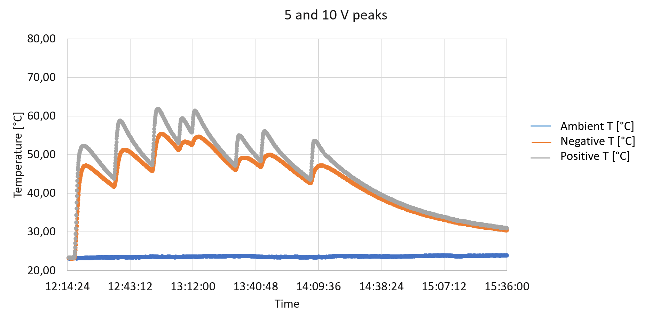

Figure 8: Temporal results of the temperature reached in a series connection of two new lithium batteries and subjected to overvoltage peaks of 5 and 10 V

4. Conclusions

When a new lithium battery with a manganese dioxide cathode is subjected to a small overvoltage, the temperature on the battery surface reaches high values, and gas leakage also occurs. Following the attainment of the maximum temperature within a relatively brief interval, a rapid decline ensues, subsequently giving way to a period of stabilization. The most hazardous scenario transpires within a few minutes of the onset of the overvoltage. When the battery was subjected to overvoltage values that were twice as high as the initial values, the temperature increase was found to be minimal. The same process in a discharged battery resulted in a moderate temperature increase at high overvoltages and prolonged exposures. Nevertheless, the rise in temperature was found to be insignificant when low overvoltages were employed.

When these overvoltages were applied to a partially charged battery, the temperature increases were also minimal at low overvoltages. However, at high overvoltages, the temperature reached a high level, which resulted in a short circuit and fire in the cables connecting the batteries. Therefore, as the battery discharges, the probability of damage increases when subjected to high overvoltages. When overvoltages were applied to two new batteries connected in parallel, the highest temperature was observed in the parallel-connected battery, with a temperature difference of 10 °C relative to the battery connected directly to the power supply. Moreover, high overvoltages resulted in a slight increase in temperature relative to that achieved with low overvoltages.

However, when overvoltages were applied to two new batteries connected in series, the temperature increase was 10 °C lower than when they were connected in parallel, and the temperature reached was higher in the battery connected to the positive pole of the power supply. Furthermore, the temperature difference between the two series-connected batteries was found to be half that in the parallel configuration. It was thus established that parallel battery connections are prone to a greater temperature increase, particularly in instances where the battery is arranged in parallel and not directly connected to the power supply.

The present study is subject to several limitations, the first of which pertains to the extrapolation of results to multiple batteries connected in series or parallel, a scenario that would be relevant for large-scale battery storage. The subsequent limitations can be addressed through the following proposed research lines:

First, the experiments do not currently represent large-scale storage systems, thus necessitating larger-scale studies; Second, variability in manufacturing and aging characteristics is not currently considered, and thus, this variability should be incorporated into future studies. Conduct experiments with a larger number of batteries to observe the propagation of overvoltages. Third, advanced modeling: Develop models that consider battery variability and environmental factors. Finally, consideration of other types of lithium batteries: Investigate whether the results obtained are applicable to other types of lithium batteries. This work will allow a more complete understanding of the risks associated with overvoltages and will facilitate the development of more effective safety strategies.

References

Diaz L. B., He, X., Hu Z., Restuccia F., Marinesc, M., Barreras J. V., ... & Rein G., 2020. Meta-review of fire safety of lithium-ion batteries: Industry challenges and research contributions, Journal of The Electrochemical Society, 167(9), 090559.

Kim S. H., Waldhoff S. T., & Edmonds J. A., 2023, The Role of Battery Electric Vehicles in Deep Decarbonization, Climate Change Economics, 14(01), 2350004.

Lisbona D., & Snee T., 2011, A review of hazards associated with primary lithium and lithium-ion batteries, Process safety and environmental protection, 89(6), 434-442.

Morales J., Trócoli R., & Santos-Peña J., 2009, A LiFePO4-Based Cell with Li x (Mg) as Lithium Storage Negative Electrode, Electrochem. and Solid-State Lett., 12(7), A145.

Sang-Bo S., 2016, Study on the explosion and fire risks of lithium batteries due to high temperature and short circuit current, Fire Science and engineering, 30(2), 114-122.

Stampatori D., Raimondi P. P., & Noussan M., 2020, Li-ion batteries: A review of a key technology for transport decarbonization, Energies, 13(10), 2638.

Wen J., Yu Y., & Chen C., 2012, A review on lithium-ion batteries safety issues: existing problems and possible solutions, Mater. express, 2(3), 197-212.

Zhu G. L., Zhao C. Z., Huang J. Q., He C., Zhang J., Chen S., ... & Zhang Q., 2019, Fast charging lithium batteries: recent progress and future prospects, Small, 15(15), 1805389.